Administrator Guide

jWebSocket
Audio and Video transmission using jWebSocket Framework
1.0

Version Control
Date | Version | Description | Author
24/04/2012 | 1.0 | Document Creation | Alexander Rojas Hernández

- Download Application Process
To obtain the application and API for audio and video transmission please download all the packages containing the client and server jWebSocket contained in version 1.0 from the URL: http://jwebsocket.org/download/.

2. Characteristics of the installation environment for stationary application.
- OpenJDK 1.7 o or higher installed. What about Java 1.6, Java 1.7 ?
- Java Media Framework (JMF) library (jmf.jar)
- WebCam controllers installed.

3. Installation process
To run the stationary application in a browser using a java applet, the client requires an installed Java Virtual Machine (JVM).
Installation for the Linux operation system:
- Change the permissions of the downloaded file to be executable. Write:
chmod a+x jre-6u<versión>-linux-i586.bin
- Check that you have permission to run file. Write:
ls –l
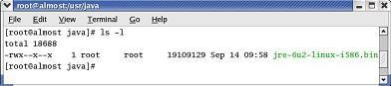

If you want change the directory where you want to install. Write
cd <directory/path>
- For example, to install in the directory /usr/java. Write:
cd /usr/java/
Note about root access: To install Java in a location accessible from the entire system, such as /usr/local, you must login as root to obtain the necessary permits. If you don’t have root access, install Java in your home directory or a subdirectory for which you have write permission.
- Run the self extracting binary. Write
./jre-6u<versión>-linux-i586.bin
Shows the license agreement, review the contract. Press the spacebar to move to next page. In the end, write yes to proceed with the installation.
- Java is installed in its own directory. In this example, it has been installed in the /usr/java/jre1.6.0_<version>. Once the installation is over will see the word Done. See, here you describe installation of Java 1.6, so please mention that above.
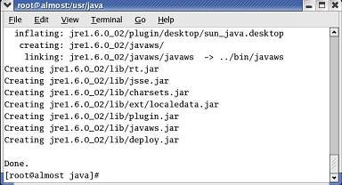

- Check that the subdirectory jre 1.6.0 appears in the content from the current directory. Write: ls
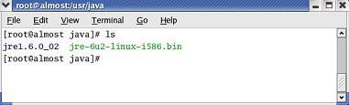

Install Java for the Windows operation system:
- Close all applications, including the browser.
- Double click the file (which file?, filename, location?) to start the installation process.
- Starts the installation process. Click the Install button to accept the license terms and continue with the installation.
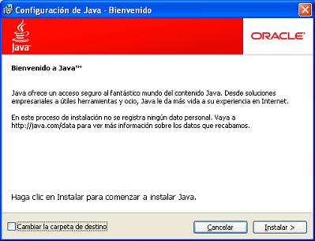

- Oracle works with companies offering different products. It is possible that the installer offers the option to install these programs as part of the Java installation. Once selected the programs you want, click the Next button to continue the installation process.
- You will see several dialog boxes with information to complete the final stages of the installation process, please click Close on the last dialog box. This action will complete the installation of Java.
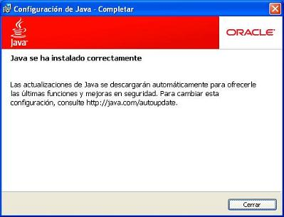
NOTE: You may need to restart (close and open) your browser to enable the installation of Java on your browser. Give examples here, how and where at least for one or two browsers, e.g. firefox and chrome.
Installation of Java Media Framework for stationary application.
Installation process
Just a headline and a screenshot? Is a bit few. At least give a sentence to the reader what to do.
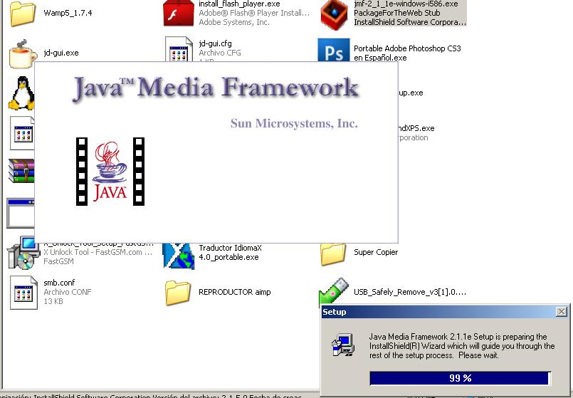
Execute JMF install(Setup)
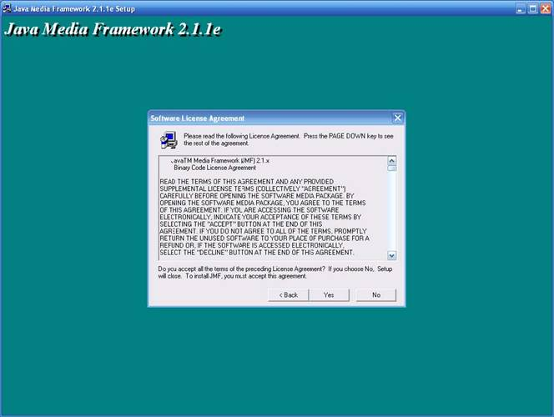
Press Yes to accept all terms.
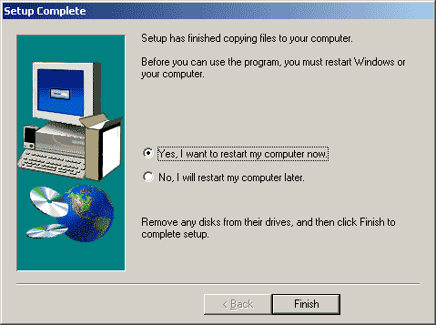
A bit few text in this chapter, give some sentences here please.

Characteristics of install enviroment for native application.
What is it about in this chapter? I suspect it is about the installation on the smartphone, here I expect at least in introductional sentence.
Installation process
The first step is copy the (“the”? Which one, how can the reader know? Where to find?) native application to the Smartphone.
Note: The native application is made for Android 2.3
- Use the Astro Manager program (what is this? Where to get? Need explanation here!) to search and run the native application.
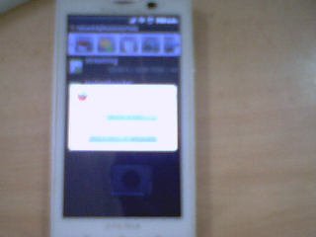
Press Open Application Manager
- Goes to intallation process
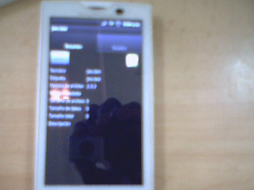
Press install
- The application is installed
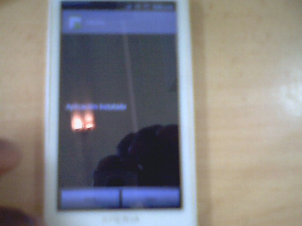

All the text here is too few. The reader at least expect some “normal sentences” Can you provide some better screenshots, these are hardly readable. Maybe you can install on the emulator and make screenshots on the PC?

3.1 Stationary Application Hardware (Important)
Make sure to the webcam´s controllers are correctly installed in the pc. This is two few! At least give an example here! What to consider? How? Explain what you used here, this will be sufficient as an example!
3.2 Native Application Hardware (Important)
Smartphone with Android 2.3. Is there anything expected going wrong with higher versions? What do you expect here?
4. Configuration Options
Don´t require any specific configuration Really? Nothing? I hardly can imagine! No config file, no options in the jWebSocket.xml? If so, fine, but please check.

5 In Runtime
Server
- Run the jWebSocket server, how? Command line example?
Stationary Application Client Side
- Connect the webcam
- Run the applet in the client browser, how? URL? Screenshot?
6. Application Management
To manage API for the management of smart cards can be supported in the user guide.
. (smart cards?) Well, copy and paste issue?

